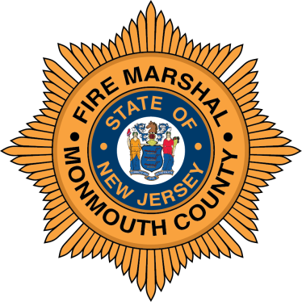

COUNTY OF MONMOUTH

OFFICE OF THE FIRE MARSHAL

1027 HIGHWAY 33 EAST

FREEHOLD, NEW JERSEY 07728-9998

FRED MIGLIACCIO OFFICE: 732-683-8856
FIRE MARSHAL FAX: 732-683-8864

March Fire Safety Tips

With Spring approaching rapidly on March 20th the Monmouth County Fire Marshal’s Office, the Board of Commissioners and the Sheriff’s Office would like to offer these Fire Safety Tips:

- Don't forget to change your clocks and batteries on your carbon monoxide detectors on Sunday, March 13th. Set your clocks ahead 1 hour and change the batteries in those smoke and carbon monoxide detectors that use batteries. Please consider replacing them with the new 10- year detectors. These detectors have tamper proof batteries that have a lifespan of the 10-year warranty.

- It's also a good time to inspect fire extinguisher and review how to use them. Make sure they are easily accessible.

- Review your home fire escape plan. Update it if there have been any changes
like such as new occupants in the home (babies, elderly relatives, etc.)

- March is also “Wildland Urban Interface” month. If you live in or near a remote
wilderness area review your escape plan and preventative measures to limit fire
danger. One way to do so is creating and maintaining a defendable space between your
property and dwellings. Keep combustibles away from your house and plan for evacuation of people with special needs and any animals/pets you may have on your property.

- The United States Fire Administration has reported 316 home fire deaths since January
1st and 13 firefighter deaths (as of February 1st) in the U.S. We need everyone's help to reduce this number.

- Make sure you safely store gasoline and propane tanks away from your house if possible. and safely store snow blowers emptied of fuel.

The Monmouth County Fire Marshal’s Office, the Board of Commissioners and the Sheriff’s Office want you to have a safe and happy Spring.

